Hughesdale Primary School Stadium Procedure

Our usage of the School stadium is under contract, and the Bentleigh Lakers has strict obligations to ensure we look after the stadium and manage the security whilst it is in our care. If we don’t meet these obligations, the Club will be at risk of losing access.
Please contact the Club Administrator, Jo Morley, on registerforlakers@gmail.com if you have any questions about these procedures.
The stadium is accessed via the staff car park on Austin Street, Hughesdale.
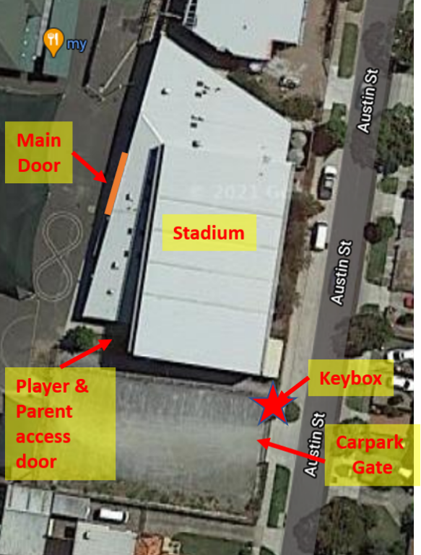

The stadium is accessed using a key and security fob kept in a lockbox.

At the end of each training session, the entire lockbox and contents must be passed on to the next Coach in person! This is not negotiable.
- Do not pass on to anyone else such as the team manager of the next team or a parent.
- Do not leave it anywhere for the next coach to find. It must be handed over in person to the next coach.
The lockbox must be kept in each coach’s possession during training.
You MUST LOCK the stadium after your session:
- If no team arrives for the next training slot, even if you are not normally the last team.
- If players arrive without a coach or responsible adult who will stay with them. Players can wait outside the stadium until their coach arrives and he/she can reopen the stadium. No unsupervised players are allowed in the stadium.
- Do not accept offers from any cleaner to lock up. Please execute the lock up procedures and the cleaners can let themselves back in.

Opening the Stadium
  - The stadium is opened/disarmed using a key and security fob located in a lockbox which is attached to the upper horizontal railing to the right of the ‘Staff Parking Only’ to the right of the car park entrance.
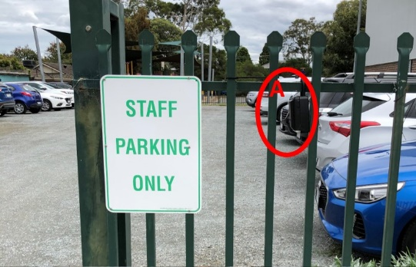
  - If you arrive and the lockbox is on the fence, YOU MUST REMOVE IT even if the stadium is open.
  - The entire lockbox is then passed IN PERSON from coach to coach.
  - The lockbox code will be sent by email to coaches. DO NOT share this code with anyone else.
  - If for some reason, you can’t take training and have arranged for another responsible adult to do so, you can share the code but please advise the Club Administrator.
  - Opening and removing the lockbox from the fence
    - Open the Black cover.
    - Move down the lever labelled ‘C’ (see B in image)
    - Enter the code.
    - Move down the 🔽 lever (see C in image) and pull open compartment door.
    - Push the little silver shackle release lever to the right to open shackle (see D in image)
    - Remove the entire lock box from fence and check that key and security fob are inside.
    - Ensure the key & fob don’t fall out of the lockbox as you move towards the main stadium door.
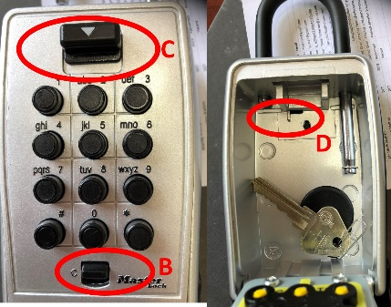
  - Opening the School Gate/Stadium (refer aerial view below)
    - Unlock the car park gate if locked.
    - Unlock the main door of stadium (see aerial photo above) and relock it from inside (no players/parents are to enter via this main door). Even if teachers are in the staff room, lock it as they have keys to get in and out.
    - Deactivate the alarm: enter the foyer and on the wall directly opposite the main door is the alarm panel. Touch the key fob to the sensor panel to deactivate the alarm if necessary (sometimes it hasn’t been activated because staff are still on the premises). Green light it is deactivated. Red light it is activated.
    - Place the key and security fob back in the lockbox and lock it (Same procedure opening the lockbox). This MUST be done as the key and fob have fallen out in the past and have been lost.
    - Enter the court area and close the large sliding door: no players or parents are to enter the stadium foyer.
    - Turn on lights: located on the left as you walk onto the court.
    - Open the player/parent access door which is down the other end of the stadium nearest the carpark – this doesn’t require a key to open – just press down the horizontal steel bar and push door open all the way.
    - Before commencing training, check the toilets and stadium area for any litter and/or damage, take a photo and report it to the Club Administrator. In the past, we’ve been blamed for issues that may not have been caused by our teams.
    - Sweep courts if necessary: there is a scissor style broom in the cleaners’ room.
    - Ventilation/Stadium Fans
      - If you feel it necessary to open the external doors on the court for ventilation, it is your responsibility to close them at the end of your training session.
      - There are fans in the court area which can be turned on if necessary. The controls are in the foyer area (see photo below
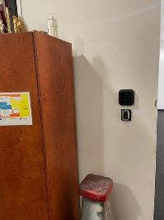

Locking the stadium
- You MUST LOCK the stadium after your session:
- If no team arrives for the next training slot, even if you are not normally the last team.
- If players arrive without a coach or responsible adult who will stay with them. Players can wait outside the stadium until the coach arrives. There should be no unsupervised players in the stadium.
- Do not accept offers from any cleaner to lock up. Please execute the lock up procedures and the cleaners can let themselves back in.
  - Check the stadium: remove any rubbish and place in bin. Grab any clothing, drink bottles and balls left during training and take it with you. The school will not take any responsibility for lost property. Take a photo of any damage caused during training and report to the Club Administrator.
- Check that all doors are locked: both entrance doors to the foyer, 2 fire exits, 2 external doors from the girls’ and boys’ toilets which need to be locked from the outside with a key if they have been opened from the inside.
- Turn off all the lights and fans (refer ‘Opening the Stadium’ instructions for light and fan control locations.
- Close external doors.
- Activate the alarm: Locate the alarm panel on the wall opposite the main entrance door and tap the plastic fob on the key ring on the panel. The green light will change to red and there will be a beep.
- Lock the main door of the stadium – you have around 10 seconds to lock the door.
- Close the pedestrian gate between the carpark and school grounds with the stadium key.
- Lock the carpark gate with the stadium key.
- Return the lockbox to the exact same place on the fence: the upper horizontal railing to the right of the ‘Staff Parking Only’ to the right of the car park entrance. Ensure its locked and attached securely.
- Never remove the keys or alarm fob from the school.

Using the Stadium
- No unsupervised players are allowed in the stadium, even if the stadium is open (staff may be in the adjoining rooms).
- We have access to the court and toilets. All other areas are OUT OF BOUNDS:
- the foyer is OUT OF BOUNDS (except for the coach when opening and closing the stadium).
- School grounds/playgrounds etc cannot be used by any parents, players or siblings etc before, during, or after training.
- The stadium is to be used for the teams allocated training time ONLY. Use of the stadium outside of the team’s allocated training spot is PROHIBITED. Any change in allocated training spot must be approved by the Club Administrator.
- No school equipment or furniture e.g. chairs are to be touched, disturbed or moved.
- All siblings of players must be supervised by a parent/guardian including when using the toilets.
- Use only sports shoes. No high heels are to be worn on the court.

