Valkstone Stadium Procedures

School stadium usage is under contract, and we have strict obligations to ensure we look after the stadium and manage the security whilst it is in our care. If we don’t meet these obligations, the Club will be at risk of losing access. Access to the stadium is via a key and security fob kept in a key lockbox.
Please contact the Club Administrator, Jo Morley, on regsterforlakers@gmail.com if you have any questions about these procedures.
The stadium is located at 44 Valkstone Street, East Bentleigh. The stadium is accessed using the pedestrian gate shown in the aerial view below.
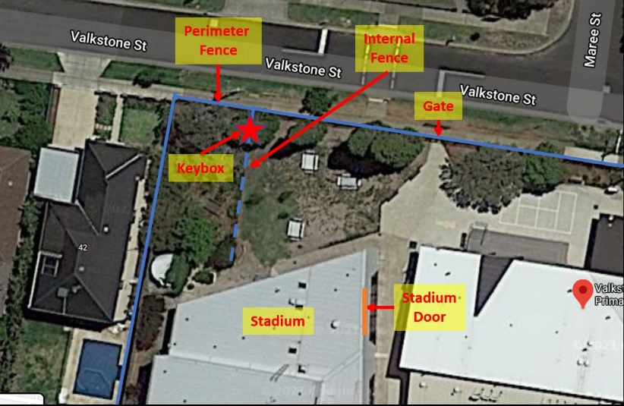
The stadium is accessed using a key and security fob kept in a lockbox.
At the end of each training session, the entire lockbox and contents must be passed to the next coach in person! This is not negotiable.
- Do not pass it to anyone else such as the team manager or a parent.
- Do not leave it anywhere for the next coach to find. It must be handed over in person to the next coach.
The lockbox must be kept in the coach’s possession during training.
The coach MUST LOCK the stadium after the training session:
- If no team arrives for the next training spot, even if you’re not normally the last team.
- If players arrive without a coach or responsible adult who will stay with them. Players can wait outside the gates until their coach arrives and he/she can reopen the stadium. No unsupervised players are allowed in the school grounds.
- Do not accept offers from any cleaner to lock up. Please execute the lock up procedures and the cleaners can let themselves back in.
- If there are still teachers in the adjoining rooms, advise them that you are leaving, and the stadium is empty and they can lock up.

- Coach to Coach Procedure
  - The first coach using the stadium for the night must remove the lockbox from the fence regardless of whether the stadium and gate is open or not. The lockbox contains the stadium/gate key and security fob and is attached to the internal fence near where it meets the perimeter fence towards the right-hand side of the school grounds (see aerial photo above and photo below).
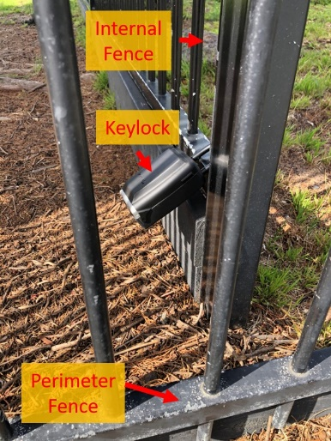
  - At the end of each training session, the entire locking system must be passed on to the next Coach in person! Every piece of the locking system must be handed to the next Coach – this is not negotiable.
Do not pass on to anyone else such as the team manager of the next team or a parent.
Do not leave anywhere for the next coach to find. It must be handed over in person.
  - The lockbox must be kept in each coach’s possession during training.
  - The last coach that trains is responsible for locking up the stadium and gate and returning the entire lockbox to the fence railing. The entire lockbox and its contents need to be passed from “Coach to Coach” at end of each session. If no team arrives to coach after your session, you MUST LOCK the stadium and school gate even if you are not normally the last team.
  - Do not accept offers from any cleaner to lock up. Please execute the lock up procedures and the cleaners can let themselves back in.
  - Never remove the keys, alarm fob or lockbox from the school.

- Opening and removing the lockbox from the fence
  - Open the Black cover
  - Move down the clear button (see B in image)
  - Enter the code (this will be sent to you by the Age Group Coordinator)
  - Move down the 🔽 button (see C in image) and pull open compartment door.
  - Push the little silver shackle release lever to the right to open shackle and release the lockbox from the fence (see D in image)
  - Remove the entire lock box from fence and check that key and security fob are inside.
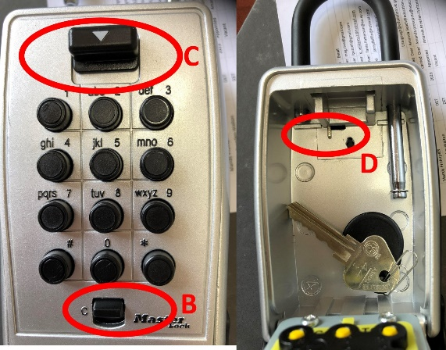
- Opening the School Gate & Stadium
  - Open the perimeter gate with the stadium key.
  - Open the main door to the stadium (see aerial photo above), turning the key anti-clockwise. You may need to gently push the door forward whilst doing so.
  - Enter the stadium and turn immediately left. About 2m along the wall is the alarm panel. It is the size of a power point with a red light at the bottom of the panel.
  - Deactivate the alarm if necessary. With the white side of the security fob facing the alarm panel, slowly swipe the security fob from top to bottom once only. Red light activated. Green light deactivated. Only swipe once – if you swipe twice, it will turn the alarm off and then back on again!
  - Lock the lockbox so the key/fob do not fall out (Same procedure as opening - steps 2.2-2.4)
  - Before commencing training:
      - Check the entry area, court area and toilets for any litter and/or damage, take a photo and report it to the Club Administrator. In the past we’ve been blamed for issues that may not have been caused by our teams.
      - There is a scissor style broom in the cleaners’ room if you need to sweep the floor.
      - If you feel it necessary to open the external doors on the court for ventilation it is your responsibility to close them at the end of your training session.

- Locking the stadium
  - Check the stadium: remove any rubbish and place in bin. Grab any clothing and balls left during training and take it with you. The school will not take any responsibility for lost property. Ensure the stadium door facing Valkstone Rd is locked (sometimes kids or parents unlock it). Take a photo of any damage caused during training and report it immediately to the Club Administrator.
  - Close any external court doors and turn off the lights.
  - Activate the alarm: Locate the alarm panel to the right of the main door – it is about 2m from the door. Swipe the plastic security fob on the key ring (from top to bottom) over the panel. The green light will change to red and there will be a beep.
  - Lock the stadium – you have around 10 seconds and lock the door. The key turns clockwise. You may have to push the door slightly.
  - Lock the perimeter gate.
  - Return the lockbox to the exact same place on the fence. Ensure its locked and attached securely.
Using the Stadium
- No unsupervised players are allowed in the school grounds, even if the gates/stadium are open (staff may be in the adjoining rooms or cleaners may be in there)
- We have access to the entry area, court and toilets. All other areas are OUT OF BOUNDS. There is to be no use of the school grounds/playgrounds etc by any parents, players or siblings etc before, during, or after training.
- The stadium is only to be used for the allocated training time ONLY. Use of the stadium outside the team’s allocated training spot is PROHIBITED. Any change in allocated training time must be approved by the Club Administrator.
- All siblings of players must be supervised. If siblings need to use the toilets, then a parent must go with them
- Use only sports shoes. No high heels are to be worn on the court.

