McKinnon Primary School Stadium Procedure

Our usage of the School stadium is under contract, and the Bentleigh Lakers has strict obligations to ensure we look after the stadium and manage the security whilst it is in our use. If we don’t meet these obligations, the Club will be at risk of losing access.
Please contact the Club Administrator, Jo Morley, on registerforlakers@gmail.com if you have any questions about these procedures.
The stadium is accessed via the Tucker Road gate and by walking through the school. The Collins street gate is locked.
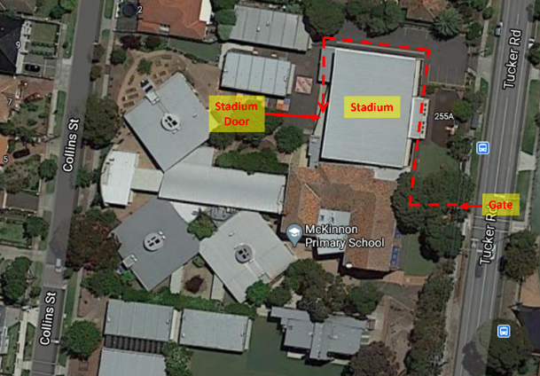

You MUST LOCK the stadium after your session:
- If no team arrives for the next training slot, even if you are not normally the last team.
- If players arrive without a coach or responsible adult who will stay with them. Players can wait outside the stadium until the coach arrives. There should be no unsupervised players in the stadium.
- Do not accept offers from any cleaner to lock up. Please execute the lock up procedures and the cleaners can let themselves back in.

Opening the Stadium
  - The lockbox containing the key and security fob is permanently attached to the right of the stadium entry door. Our lockbox is the “Masterlock’ with the black cover (see photo below). The lockbox code will be sent by to coaches by the Club Administrator. DO NOT share this code with anyone else.
  - Opening the lockbox
    - Open the black cover
    - Move down the bottom lever with ‘C’ near it (see B in image)
    - Enter the code (this will be sent to you by the Club Administrator)
    - Move down the 🔽 lever (see C in image) and pull open compartment door.
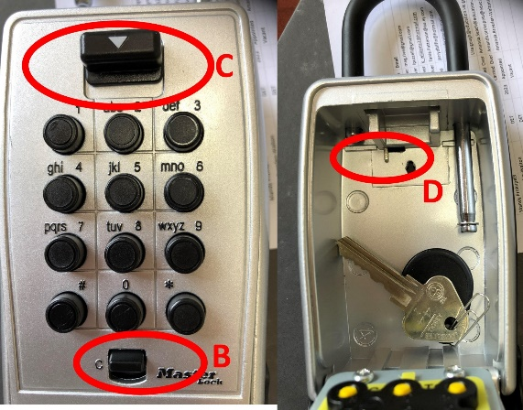
    - If for some reason, you can’t take training and have arranged for another responsible adult to do so, you can share the code but please advise the Club Administrator.
    - There is a chance that the After School Hours Care team will still be in the stadium when you arrive, and the stadium will be open and the security disarmed. In this case, you can then proceed to use the court.
  - Unlock the stadium door.
  - Deactivate the alarm: after entering the stadium, turn immediately right to locate the alarm panel and light switches. Place the number side of the security fob against the alarm box. You have about 10 seconds to do this before the alarm goes off.
- The green light on alarm means the alarm is DEACTIVATED and you can access the court.
- The red light on alarm means the alarm is ACTIVATED and you must deactivate before use.
  - Immediately return the key & fob to the lockbox, lock it and scramble the code:
- To lock it, exactly follow the same process as opening it.
- Do not let anyone else do this.
- Do not place them in your pocket etc thinking to place them back in the lockbox later.
- Do not leave them anywhere else for the next coach to find.
  - Before commencing training, check the toilets and stadium area for any litter and/or damage, take a photo and report it to the Club Administrator. In the past, we’ve been blamed for issues that may not have been caused by our teams.

Locking the stadium
  - You MUST LOCK the stadium after your session:
    - If no team arrives for the next training slot, even if you are not normally the last team.
    - If players arrive without a coach or responsible adult who will stay with them. Players can wait outside the stadium until the coach arrives. There should be no unsupervised players in the stadium.
    - Do not accept offers from any cleaner to lock up. Please execute the lock up procedures and the cleaners can let themselves back in.
  - Check the stadium: remove any rubbish and place in bin. Grab any clothing and balls left during training and take it with you. The school will not take any responsibility for lost property. Take a photo of any damage caused during training and report to the Club Administrator.
  - Check all external doors are locked. Note: you cannot do this from the inside. All the doors can be opened from the inside in case of emergencies. You need to check that the doors cannot be opened from the outside. This includes the external doors in the toilet areas.
  - Remove the key and fob from the lockbox: See instructions under ‘Opening the Stadium’.
  - Activate the alarm: See instructions under ‘Opening the Stadium’.
  - Lock the stadium – you have around 10 seconds to lock the door before the alarm goes off.
  - Return the key/fob to the lockbox, lock it and scramble the code.
- Never remove the keys or alarm fob from the school.

Using the Stadium
- No unsupervised players are allowed in the stadium, even if the stadium is open (sometimes After School Hours Care staff may still be in the stadium).
- We have access to the court, toilets and the entry area ONLY. All other areas are OUT OF BOUNDS:
- the alcove on the far side is for After School Hours Care use ONLY.
- School grounds/playgrounds etc cannot be used by any parents, players or siblings etc before, during, or after training.
- The stadium is to be used for the teams allocated training time ONLY. Use of the stadium outside of the team’s allocated training spot is PROHIBITED. Any change in allocated training spot must be approved by the Club Administrator.
- No school or After School Hours Care equipment, toys or furniture is to be touched, disturbed or moved. Please do not use the stacked chairs - parents will need to use the chairs along the western side of the court or stand or sit on the floor.
- All siblings of players must be supervised by a parent/guardian including when using the toilets.
- Use only white soled shoes. No high heels are to be worn on the court.

